KOM / Sprint / Best Master Results

Round 2 - April 19, 2014

CATEGORY 4

KOM # 1 Presented by BikeReg.com
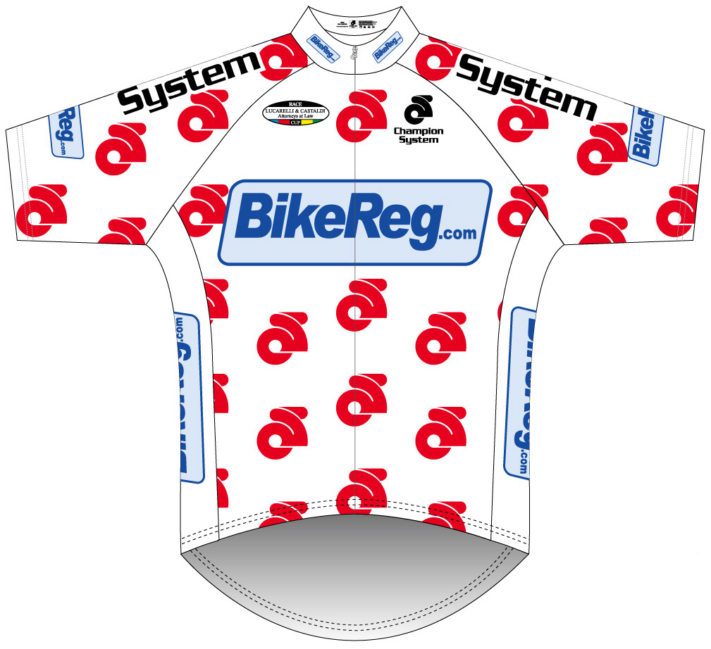
- Patrick Grehan (Kissena)
- Saul Jacobson (BVF)
- Stanislaw Arciszewski (Unatt)

KOM # 2 Presented by BikeReg.com

- Louisgie Shoy (MBCR)
- Patrick Grehan (Kissena)
- Saul Jacobson (BVF)

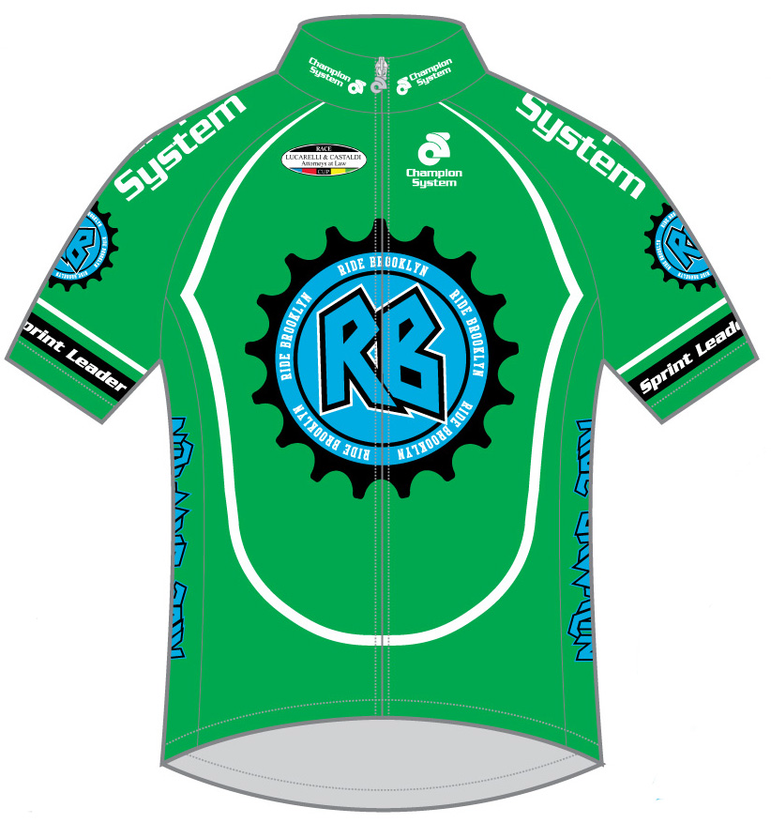
SPRINT # 1 Presented by Ride Brooklyn

- Jun Sugai (Chari & Co)
- Edikson Pena (Montecci)
- Erik Fernandez (CRCA/Dave Jordan)

SPRINT # 2 Presented by Ride Brooklyn

- Steven Patak (CIS First Team)
- Rob Havenmeyer (GBSC)
- Erik Fernandez (CRCA/Dave Jordan)

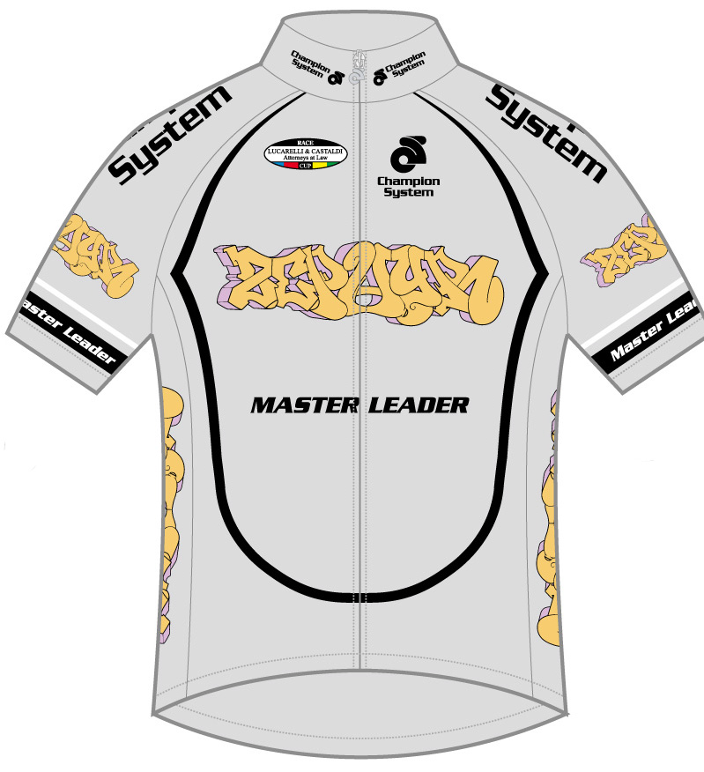
Best Master Competition Presented by Zephyr Graffiti

- Louisgie Shoy (MBCR)
- Stanislaw Arciszewski (Unatt)
- Daniel Diaz (Manpower Bike)
- Jason Jones (Watchung Wheelmen)
- Sebaj Adele (Unatt)

